Liverpool Angelican Cathedral

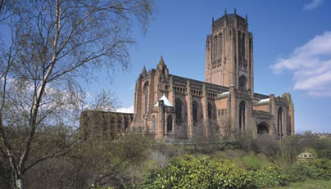

Liverpool Cathedral Information
The largest Anglican Cathedral in Britain and one of the great buildings of the twentieth century. The massive tower stands over the city as a symbol of faith in God amidst the bustle of the modern world.
The Cathedral abounds in superlatives: highest gothic arches, largest organ, heaviest ring of bells but the grandeur is balanced by a great sense of welcome and peace. The whole Cathedral is used imaginatively for many purposes - worship, concerts, exhibitions, recitals, displays.
History
1901 - Decision made to build a great Cathedral for the recently formed Diocese of Liverpool. Giles Gilbert, twenty two years old, won the competition to be the architect.
1904 - Foundation stone laid by King Edward VII
1910 - lady Chapel completed and used for worship.
1924 - High Altar, Chancel and the Eastern Transepts were consecrated. They formed the first section of the main cathedral, built to erve a city and a world changed by the horrors of the world war I.
The young architect then changed his mind over the design, leaving plans for two towers, choosing instead for one massive tower over a wonderfully wide central space.
1941 – Completed second phase of the Cathedral under the tower used for the irst time.
During World War 2 (1939-1945) work continued slowly, and and in a city where many buildings were severaly damaged by bombs, the Cathedral escaped completely unexpected.
1978 – Queen Elizabeth II attended the dedication of the west end of the Cathedral. The building now was completed!
Some of the unique furnishings and features added to the Cathedral since its comletion can be seen in the following locations…….
The lady chapel
statue of the Virgin Mary by
16th century sculptor Giovanni della Robbia
presented in 1929
SPCK Book/Gift Shop
The Bookshop and estaurant, designed by
Keith Scott opened in 1984
Above the west door
(on the outside the wall)
Statue of the Risen Christ by
Dame Elizabeth Frink was
dedicated in 1993
Central space and Choir
4 painting of the Parables
gifts to the Cathedral by the
Jerusalem trust in 1966
Chapter House
by Craigie Aitchison
commissioned with a grang
from the Art Lottery Fund
dedicated in 1998

Facts and Figures
The largest Anglican Cathedral in Britain and Europe, and fifth largest in the world
Length: 619 feet (189m)
Area: 104,275 sq.ft (9688sq.m)
Height of Tower: 331 feet 9101m)
Under tower Vault: 175 feet (53m)
Choir Vault: 116 feet (35m)
Nave Vault: 120 feet (37m)
Tower Arches: 107 feet (33m)
Bells: highest and heaviest peal in the world.
Organ: 9765 pipes

